1. ARP Capture & Analysis (Theory + Practical)
Practical Steps (Wireshark)
- Open Wireshark.
- Select your active network interface (Wi-Fi/Ethernet).
- Apply filter:
arp
- Start capture.
- Trigger ARP by:
  - Ping router:
ping <router_ip>
- Observe:
  - ARP Request → “Who has IP X.X.X.X? Tell Y.Y.Y.Y”
  - ARP Reply → “X.X.X.X is at MAC XX:XX:XX:XX:XX:XX”

Theory Explanation
- ARP (Address Resolution Protocol) maps IP → MAC address.
- Communication inside a LAN requires MAC addresses.
- When a device wants to send data:
  - It checks ARP cache.
  - If not found → sends broadcast ARP request.
  - Router/device replies with MAC.
Importance in Packet Forwarding
- Without ARP → device cannot find destination MAC.
- Ensures correct delivery of packets within LAN.
- Used before every first communication with a device

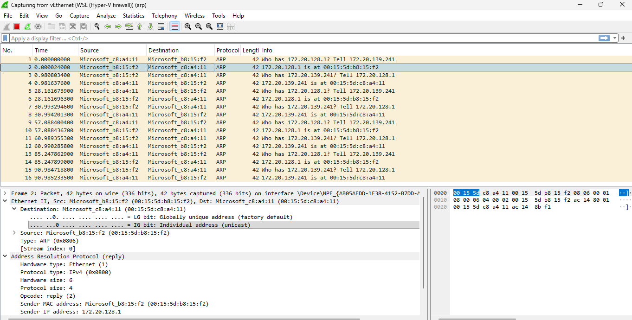
2. Static Routing
Theory
Static routing is a method where routes are manually configured by the network administrator to control how packets travel between different networks. Unlike dynamic routing, it does not automatically update routes.
In static routing, the router is explicitly told:
- Destination network
- Subnet mask
- Next-hop IP address (gateway)
Practical Configuration (Cisco Router)
Scenario
Two networks:
- Network 1 → 192.168.1.0/24
- Network 2 → 192.168.2.0/24
Router interfaces:
- R1 → 10.0.0.1
- R2 → 10.0.0.2

Step 1: Configure Static Route
On Router 1:
ip route 192.168.2.0 255.255.255.0 10.0.0.2
On Router 2:
ip route 192.168.1.0 255.255.255.0 10.0.0.1

Step 2: Verify Configuration
Check Routing Table
show ip route
Test Connectivity
ping 192.168.2.1
Trace Path
traceroute 192.168.2.1

Working Explanation
- A packet from Network 1 is sent to Router 1.
- Router 1 checks its routing table.
- It finds the static route and forwards the packet to 10.0.0.2 (next hop).
- Router 2 then delivers the packet to the destination network.

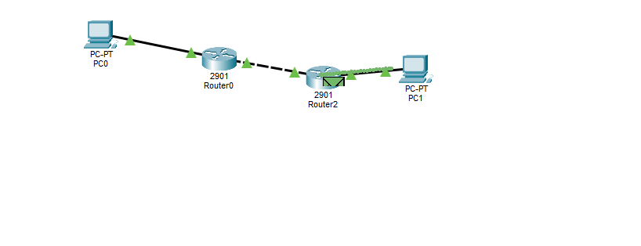

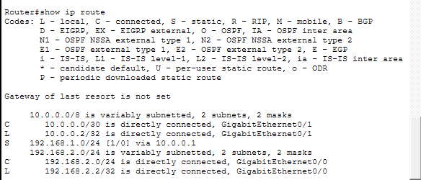

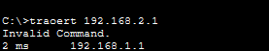

3 ) Subnetting 10.0.0.0/24 into 4 Equal Subnets
Step 1: Calculate the New Subnet Mask
To divide into 4 subnets, we need 2 additional bits (2² = 4).
Original: /24 → New: /24 + 2 = /26
Detail | Value
Original Mask | 255.255.255.0
New Subnet Mask | 255.255.255.192
Subnet bits borrowed | 2
Block size | 256 − 192 = 64

Step 2: Valid Host Ranges for Each Subnet
Each subnet has 64 addresses → 62 usable hosts (subtract network & broadcast).
Subnet | Network Address | First Host | Last Host | Broadcast
Subnet 1 | 10.0.0.0/26 | 10.0.0.1 | 10.0.0.62 | 10.0.0.63
Subnet 2 | 10.0.0.64/26 | 10.0.0.65 | 10.0.0.126 | 10.0.0.127
Subnet 3 | 10.0.0.128/26 | 10.0.0.129 | 10.0.0.190 | 10.0.0.191
Subnet 4 | 10.0.0.192/26 | 10.0.0.193 | 10.0.0.254 | 10.0.0.255

Step 3: Assign IPs in Packet Tracer
A typical 4-subnet topology setup:
Device | Subnet | IP Address | Subnet Mask
Router Interface 1 | Subnet 1 | 10.0.0.1 | 255.255.255.192
PC1 | Subnet 1 | 10.0.0.2 | 255.255.255.192
Router Interface 2 | Subnet 2 | 10.0.0.65 | 255.255.255.192
PC2 | Subnet 2 | 10.0.0.66 | 255.255.255.192
Router Interface 3 | Subnet 3 | 10.0.0.129 | 255.255.255.192
PC3 | Subnet 3 | 10.0.0.130 | 255.255.255.192
Router Interface 4 | Subnet 4 | 10.0.0.193 | 255.255.255.192
PC4 | Subnet 4 | 10.0.0.194 | 255.255.255.192
Step 4: Verify Connectivity in Packet Tracer
Use the ping command from each PC:
ping 10.0.0.1 ← ping default gateway
ping 10.0.0.66 ← ping device in another subnet
Use traceroute to trace the path:
tracert 10.0.0.130

4. IP Address Analysis
Given IPs
- 192.168.10.5
- 172.20.15.1
- 8.8.8.8

Class Identification
IP Address | Class | Range
192.168.10.5 | Class C | 192–223
172.20.15.1 | Class B | 128–191
8.8.8.8 | Class A | 1–126

Private vs Public
IP | Type | Reason
192.168.10.5 | Private | 192.168.x.x reserved
172.20.15.1 | Private | 172.16–31 reserved
8.8.8.8 | Public | Internet (Google DNS)

NAT Explanation
Theory
NAT (Network Address Translation) converts:
- Private IP → Public IP
Working
- Device sends packet (source = private IP)
- Router replaces source IP with public IP
- Internet replies to public IP
- Router maps back to private IP

Example
Before NAT:
Source: 192.168.1.10 → Dest: 8.8.8.8
After NAT:
Source: 203.0.113.1 → Dest: 8.8.8.8
5. NAT Configuration with Wireshark Validation
Theory
Network Address Translation (NAT) is a technique used to convert private IP addresses into public IP addresses so that devices in a local network can communicate with external networks such as the internet.
In a network:
- The inside network uses private IP addresses (for example, 192.168.1.x).
- The outside network uses public IP addresses (for example, 200.1.1.1).
NAT improves security by hiding internal IP addresses and also helps in conserving public IP addresses. A common type of NAT used is PAT (Port Address Translation), where multiple devices share a single public IP address using different port numbers.

Practical Setup
Topology
A simple network is created with:
- One PC
- One switch
- One router
- One server (representing the internet)
Connection:
PC → Switch → Router → Server

IP Addressing
PC:
- IP Address: 192.168.1.10
- Subnet Mask: 255.255.255.0
- Default Gateway: 192.168.1.1
Router:
- Inside Interface (g0/0): 192.168.1.1
- Outside Interface (g0/1): 200.1.1.1
Server:
- IP Address: 200.1.1.2

Router Configuration
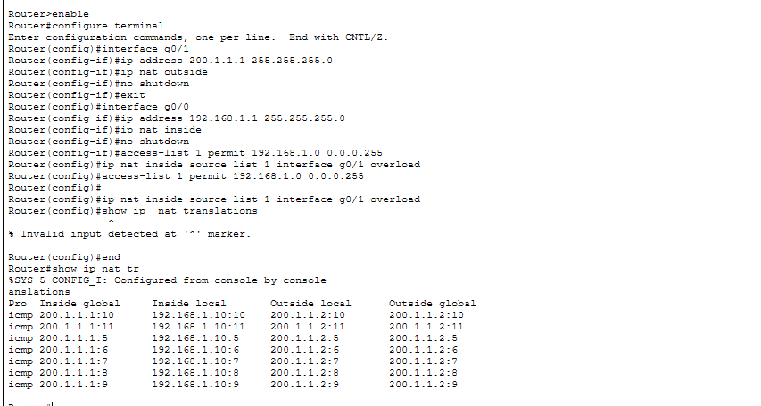
Testing
From the PC, send a ping to the server:
ping 200.1.1.2
If the configuration is correct, the ping will be successful.
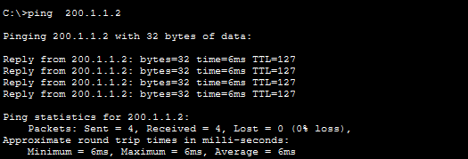

Verification
To check NAT translation in the router:
show ip nat translations
This will display the mapping between private and public IP addresses, such as:
- 192.168.1.10 mapped to 200.1.1.1

Wireshark / Packet Analysis
Since direct integration with Wireshark is not available in Cisco Packet Tracer, packet analysis is done using Simulation Mode.
Before NAT (inside network):
- Source IP: 192.168.1.10
- Destination IP: 200.1.1.2
After NAT (outside network):
- Source IP: 200.1.1.1
- Destination IP: 200.1.1.2
This shows that the private IP address is translated into a public IP address.

